Lab 01: Classes and Objects
Exercise 1: Creating a Car Class
Student Name: Jichichi Clive T
Registration Number: H250254B
Programme: Software Engineering
Date: 8/10/2026
Exercise 1
Aim
To demonstrate the use of classes and objects in Java by creating a Car class with instance fields, a constructor and a method for displaying car information.
Procedure
- Opened Apache NetBeans IDE and created a Java application named Lab01ClassesAndObjects.
- Created a Java class named Car.
- Declared three instance fields: brand, year and mileage.
- Created a constructor to initialize the fields of each car object.
- Implemented the display() method to print the details of a car.
- Created a Main class containing the main() method.
- Created three car objects with different brands, manufacturing years and mileage values.
- Called the display() method for each object.
- Saved and executed the program in NetBeans to verify that it compiled and produced the expected output.
Source Code
Car.java
/**
*
* @author ProBook
*/
// Declares a class named Car to represent a car
public class Car {
// Declares instance fields to store each car's information
String brand; // Stores the brand or name of the car
int year; // Stores the year the car was manufactured
double mileage; // Stores the distance travelled by the car in kilometres
// Constructor used to initialize a Car object when it is created
public Car(String brand, int year, double mileage) {

// Assigns the supplied brand to this car's brand field
this.brand = brand;
// Assigns the supplied manufacturing year to this car's year field
this.year = year;

// Assigns the supplied mileage to this car's mileage field
this.mileage = mileage;
}
// Declares a method that displays the details of a car
public void display() {
// Prints the car's brand
System.out.println("Brand: " + brand);

// Prints the car's manufacturing year
System.out.println("Year: " + year);

// Prints the car's mileage followed by the unit
System.out.println("Mileage: " + mileage + " km");

// Prints a separator to make the output easier to read
System.out.println("--------------------");
}
Main.java:
// Declares the Main class, which starts the program
public class Main {

// The main method is the entry point of the Java application
public static void main(String[] args) {

// Creates the first Car object with its brand, year and mileage
Car car1 = new Car("Toyota", 2018, 65000);

// Creates the second Car object with its own information
Car car2 = new Car("Honda", 2015, 82000);

// Creates the third Car object with its own information
Car car3 = new Car("BMW", 2022, 30000);

// Calls the display() method to print the first car's details
car1.display();

// Calls the display() method to print the second car's details
car2.display();

// Calls the display() method to print the third car's details
car3.display();
}
}
Program Output
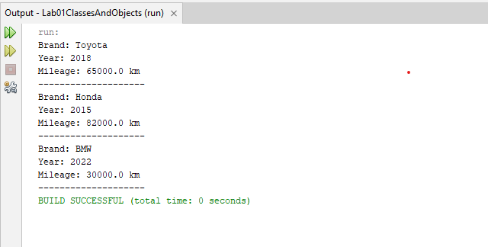
Explanation of the Program
Class: The Car class serves as a blueprint for creating car objects. It defines the information each car stores and the behaviour it can perform.
Instance fields: The fields brand, year and mileage store the details of each individual car. Each object can have different values for these fields.
Constructor: The Car() constructor initializes an object when it is created. It receives the brand, year and mileage as parameters.
Objects: The statements creating car1, car2 and car3 produce three separate instances of the Car class.
The this keyword: The keyword this refers to the current object. For example, this.brand = brand assigns the supplied brand value to the object's brand field.
Method: The display() method prints the information stored in a car object. Calling car1.display() displays the details of the first car, while the other calls display the details of the remaining cars.
Conclusion
The exercise successfully demonstrated the basic principles of object-oriented programming in Java. A Car class was created with instance fields, a constructor and a method for displaying information. Three objects were instantiated with different values, demonstrating how multiple objects can be created from one class while maintaining their own data.
Exercise 2: Checking Whether a Car Is an Antique
Aim: To implement a Boolean method that determines whether a car is more than 25 years old.
Procedure:
- Added the isAntique() method to the existing Car class.
- Retrieved the current year and calculated each car's age.
- Returned true when the age was greater than 25 and false otherwise.
- Created three car objects with different manufacturing years and tested the method.
Result: The Toyota manufactured in 2018 returns false, while the Honda manufactured in 1995 and BMW manufactured in 2000 return true in 2026.
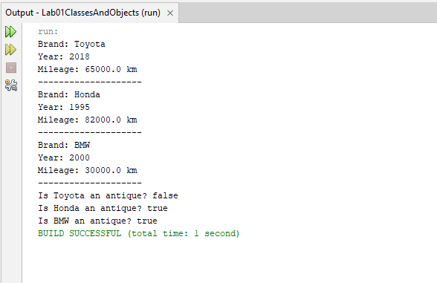
Explanation: The method uses a Boolean return type because its result is either true or false. The condition age > 25 determines whether the car qualifies as an antique according to the exercise.
Conclusion: The exercise demonstrated how a Java method can use a condition and return a Boolean value to make a decision based on an object's data.
Exercise 3 Rectangle Class and Finding the Largest Area
Aim
To demonstrate object-oriented programming concepts in Java by creating a Rectangle class, calculating the area and perimeter of rectangle objects, and using an array and loop to identify the rectangle with the largest area.
Procedure
- Created a Java class named Rectangle.
- Declared two instance variables, width and height, to store the dimensions of each rectangle.
- Created a constructor to initialize the dimensions when a rectangle object is created.
- Implemented the area() method to calculate the area using width multiplied by height.
- Implemented the perimeter() method to calculate the perimeter using twice the sum of the width and height.
- Created an array containing five rectangle objects in the Main class.
- Used a loop to display the dimensions, area and perimeter of each rectangle.
- Compared the areas of the rectangles and stored the rectangle with the largest area.
- Displayed the dimensions and area of the rectangle with the largest area.
Test Data and Expected Results
Rectangle | Width | Height | Area | Perimeter
1 | 5 | 4 | 20 | 18
2 | 8 | 3 | 24 | 22
3 | 6 | 6 | 36 | 24
4 | 10 | 5 | 50 | 30
5 | 7 | 4 | 28 | 22
The rectangle with a width of 10 and a height of 5 has the largest area of 50 square units.
Output
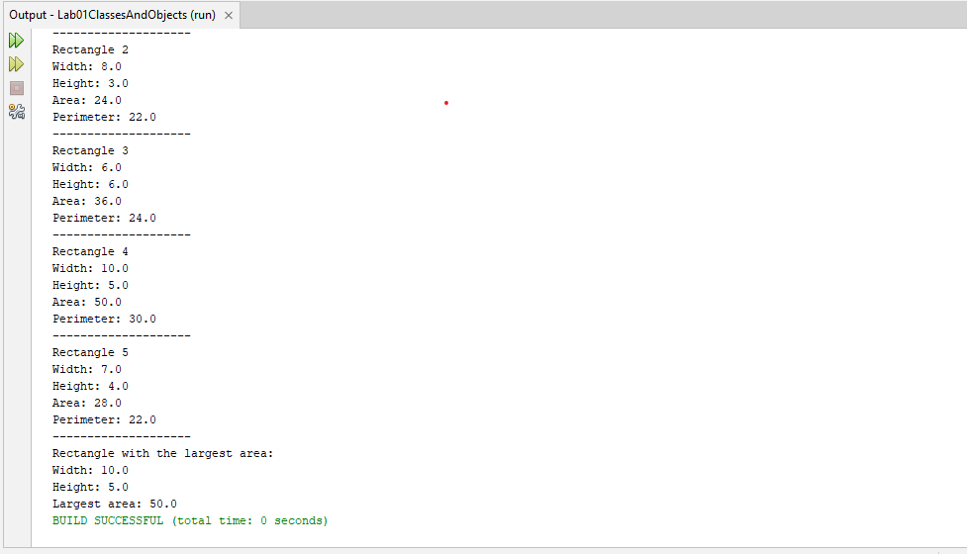
Explanation: The program uses a Rectangle class to calculate the area and perimeter of five rectangles. An array, loop, and conditional statement are used to find the rectangle with the largest area.
Conclusion: The exercise demonstrated how to create objects, use methods, and apply arrays and loops in Java to identify the rectangle with the largest area.
Exercise 4: Object References in Java
Aim: To understand how object references work in Java.
Procedure: Created a Rectangle object called r1 and assigned it to r2. Changed the width through r2 and printed the width of r1.
Source Code
Main.java
// Main class to demonstrate object references
public class Main {

// Entry point of the Java program
public static void main(String[] args) {

// Creates one Rectangle object
Rectangle r1 = new Rectangle(5, 4);

// Makes r2 refer to the same object as r1
Rectangle r2 = r1;

// Displays the original width
System.out.println("Original width of r1: " + r1.width);

// Changes the width through the r2 reference
r2.width = 10;

// Displays the width using both references
System.out.println("Width of r2: " + r2.width);
System.out.println("Width of r1 after changing r2: " + r1.width);
}
}
Output
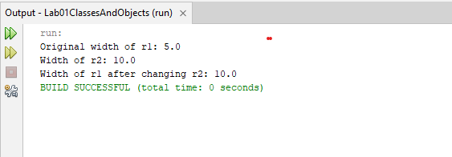
Explanation: Both r1 and r2 refer to the same object in memory. Therefore, changing r2.width to 10 also changes the width accessed through r1.
Conclusion: The exercise demonstrated that assigning one object reference to another does not create a new object. Both references access the same object.
Exercise 5: Composition and Null References
Aim: To demonstrate composition between Java classes and understand how null references are handled.
Procedure: Created Address and Person classes. A person object was given an address, and the city was accessed using chained dot notation. A second person was created without an address.
Source Code
Address.java
// Stores address information
public class Address {

// Stores the city where the person lives
String city;

// Initializes the address with a city
public Address(String city) {
this.city = city;
}
}
Person.java
// Represents a person who has an address
public class Person {

// Stores the person's name
String name;

// Stores a reference to the person's address
Address address;

// Initializes the person's name and address
public Person(String name, Address address) {
this.name = name;
this.address = address;
}
}
Main.java
// Main class to test composition and null references
public class Main {

public static void main(String[] args) {

// Creates an address object
Address address = new Address("Harare");

// Creates a person with an address
Person person = new Person("Tendai", address);

// Accesses the city using chained dot notation
System.out.println("Person's city: " + person.address.city);

// Creates a person whose address is null
Person personWithoutAddress = new Person("Tariro", null);

// Handles the missing address safely
if (personWithoutAddress.address != null) {
System.out.println("City: " + personWithoutAddress.address.city);
} else {
System.out.println("Address is not available.");
}
}
}
Output
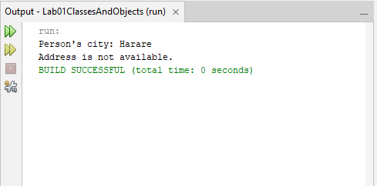
Explanation: The expression person.address.city accesses the city through the person's address object. When the address is null, checking it before accessing the city prevents a NullPointerException.
Conclusion: The exercise demonstrated how Java objects can contain references to other objects and why null references must be checked before accessing their members.

